EXPERIMENT 9
Experiment 9-1 :

<!DOCTYPE html>
<html>
<head>
<title>Array Input and Display</title>
</head>
<body style="font-size:25px;">
<h2>Enter 10 Integers</h2>

<!-- 10 input fields -->
<form id="arrayForm">
<input type="number" id="num0" placeholder="Number 1"><br><br>
<input type="number" id="num1" placeholder="Number 2"><br><br>
<input type="number" id="num2" placeholder="Number 3"><br><br>
<input type="number" id="num3" placeholder="Number 4"><br><br>
<input type="number" id="num4" placeholder="Number 5"><br><br>
<input type="number" id="num5" placeholder="Number 6"><br><br>
<input type="number" id="num6" placeholder="Number 7"><br><br>
<input type="number" id="num7" placeholder="Number 8"><br><br>
<input type="number" id="num8" placeholder="Number 9"><br><br>
<input type="number" id="num9" placeholder="Number 10"><br><br>

<button type="button" onclick="displayArray()">Display Array</button>
</form>

<h3>Output:</h3>
<p id="output"></p>

<script>
function displayArray() {
let arr = [];
for (let i = 0; i < 10; i++) {
let value = document.getElementById("num" + i).value;
arr.push(parseInt(value));
}
document.getElementById("output").innerText = "Array: " + arr.join(", ");
}
</script>
</body>
</html>

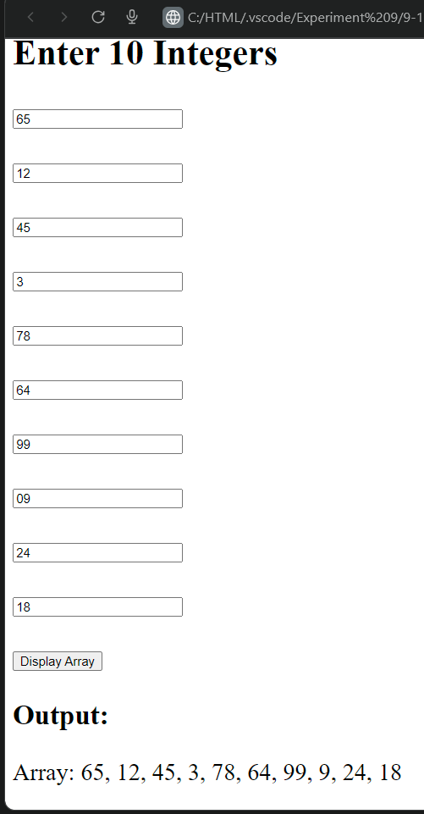

Experiment 9.2 :
<!DOCTYPE html>
<html>
<head>
<title>Find Max and Min in Array</title>
</head>
<body style="font-size:22px;">
<h2>Enter 10 Integers</h2>

<!-- Input fields -->
<form id="arrayForm">
<div id="inputs"></div>
<br>
<button type="button" onclick="findMaxMin()">Find Max & Min</button>
</form>

<h3>Result:</h3>
<p id="output"></p>

<script>
// Create 10 input boxes dynamically
let inputDiv = document.getElementById("inputs");
for (let i = 0; i < 10; i++) {
inputDiv.innerHTML += "Number " + (i + 1) +
": <input type='number' id='num" + i + "'><br><br>";
}

// Function to find max and min
function findMaxMin() {
let arr = [];
for (let i = 0; i < 10; i++) {
let value = parseInt(document.getElementById("num" + i).value);
arr.push(value);
}

let max = Math.max(...arr);
let min = Math.min(...arr);

document.getElementById("output").innerText =
"Array: " + arr.join(", ") +
"\nMaximum: " + max +
"\nMinimum: " + min;
}
</script>
</body>
</html>
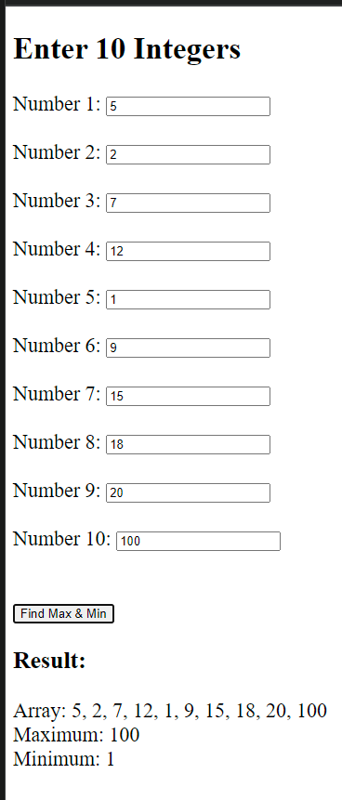
Experiment 9.3:
<!DOCTYPE html>
<html>
<head>
<title>Reverse Array</title>
</head>
<body style="font-size:22px;">
<h2>Enter Array Elements</h2>

<form id="arrayForm">
<div id="inputs"></div>
<br>
<button type="button" onclick="reverseArray()">Reverse Array</button>
</form>

<h3>Result:</h3>
<p id="output"></p>

<script>
// Ask user for array size
let size = 5; // fixed to 5 elements, you can change it
let inputDiv = document.getElementById("inputs");

for (let i = 0; i < size; i++) {
inputDiv.innerHTML += "Element " + (i + 1) +
": <input type='number' id='num" + i + "'><br><br>";
}

function reverseArray() {
let arr = [];
for (let i = 0; i < size; i++) {
arr[i] = parseInt(document.getElementById("num" + i).value);
}

// Reverse manually without built-in function
let reversed = [];
for (let i = arr.length - 1, j = 0; i >= 0; i--, j++) {
reversed[j] = arr[i];
}

document.getElementById("output").innerText =
"Original Array: " + arr.join(", ") +
"\nReversed Array: " + reversed.join(", ");
}
</script>
</body>
</html>

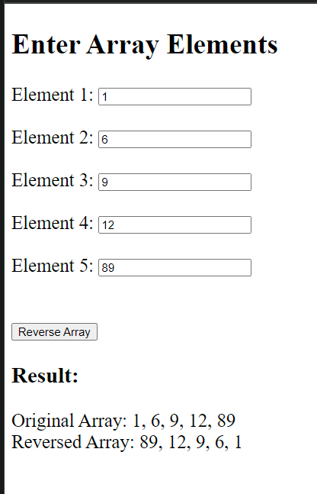

Experiment 9.4 :
<!DOCTYPE html>
<html>
<head>
<title>Linear Search</title>
</head>
<body style="font-size:22px;">
<h2>Linear Search in Array</h2>

<label>Enter array size: </label>
<input type="number" id="size" min="1">
<button type="button" onclick="createInputs()">Create</button>

<form id="arrayForm">
<div id="inputs"></div><br>

<div id="searchSection" style="display:none;">
Enter element to search:
<input type="number" id="key"><br><br>
<button type="button" onclick="linearSearch()">Search</button>
</div>
</form>

<h3>Result:</h3>
<p id="output"></p>

<script>
let size;

function createInputs() {
size = parseInt(document.getElementById("size").value);
let inputDiv = document.getElementById("inputs");
inputDiv.innerHTML = "";

for (let i = 0; i < size; i++) {
inputDiv.innerHTML += "Element " + (i + 1) +
": <input type='number' id='num" + i + "'><br><br>";
}
document.getElementById("searchSection").style.display = "block";
}

function linearSearch() {
let arr = [];
for (let i = 0; i < size; i++) {
arr[i] = parseInt(document.getElementById("num" + i).value);
}

let key = parseInt(document.getElementById("key").value);
let pos = -1;

for (let i = 0; i < arr.length; i++) {
if (arr[i] === key) {
pos = i;
break;
}
}

if (pos !== -1) {
document.getElementById("output").innerText =
"Array: " + arr.join(", ") + "\nElement " + key + " found at position " + (pos + 1);
} else {
document.getElementById("output").innerText =
"Array: " + arr.join(", ") + "\nElement " + key + " not found";
}
}
</script>
</body>
</html>

